HW9 Report

R08525103 尤梓峰

Roberts operator with threshold = 30

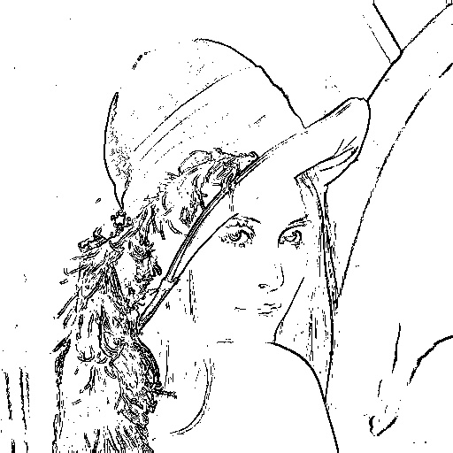

Prewitt edge detector with threshold = 24

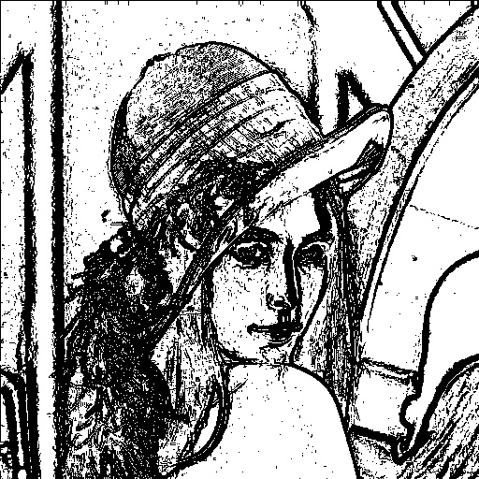

Sobel edge detector with threshold = 38

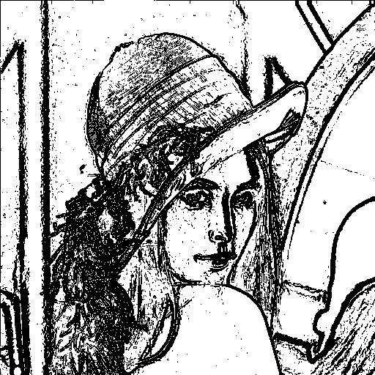

Frei and Chen gradient operator with threshold = 30

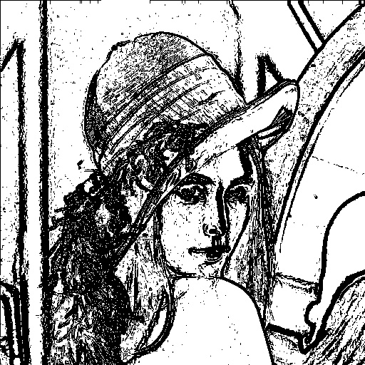

Kirsch compass operator with threshold = 135

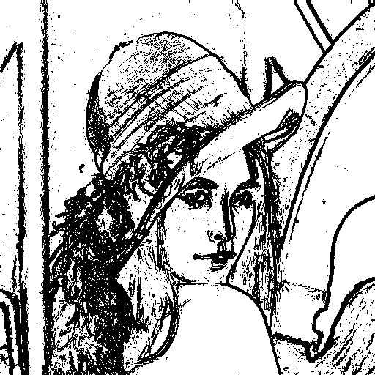

Robinson compass operator with threshold = 43

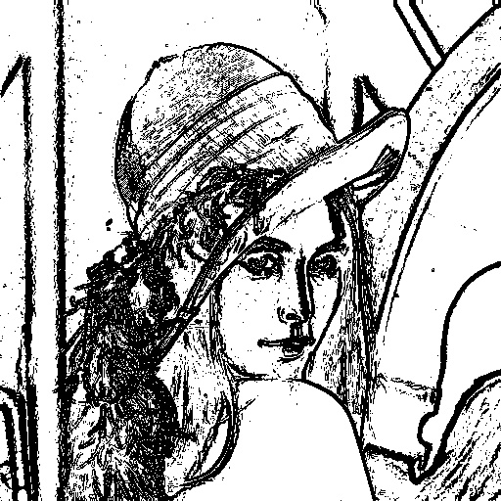

Nevatia-Babu 5×5 operator threshold = 12500

